**DAILY ONLINE ACTIVITIES SUMMARY**

|  |  |  |  |  |  |  |  |  |
| --- | --- | --- | --- | --- | --- | --- | --- | --- |
| **Date:** | **19-7-2020** | | | | | **Name:** | **Prajna** | |
| **Sem & Sec** | **8th sem ‘B’** | | | | | **USN:** | **4AL16CS067** | |
| **Online Test Summary** | | | | | | | | |
| **Subject** | | **-** | | | | | | |
| **Max. Marks** | | **-** | | **Score** | | | **-** | |
| **Certification Course Summary** | | | | | | | | |
| **Course** | **Introduction to CSS** | | | | | | | |
| **Certificate Provider** | | | **Great learning** | | **Duration** | | | **5hrs** |
| **Coding Challenges** | | | | | | | | |
| **Problem Statement:**1**.** Write a c program to find the multiplication of two matrix. | | | | | | | | |
| **Status: Completed** | | | | | | | | |
| **Uploaded the report in GitHub**  **GitHub link:** | | | | | **Yes**  **https://github.com/alvas-education-foundation/prajna_k** | | | |
| **If yes Repository name** | | | | | **prajna_k** | | | |
| **Uploaded the report in slack** | | | | | **yes** | | | |

Online Test Details: (Attach the snapshot and briefly write the report for the same)

Certification Course Details: (Attach the snapshot and briefly write the report for the same)

Coding Challenges Details: (Attach the snapshot and briefly write the report for the same)

2) certification course

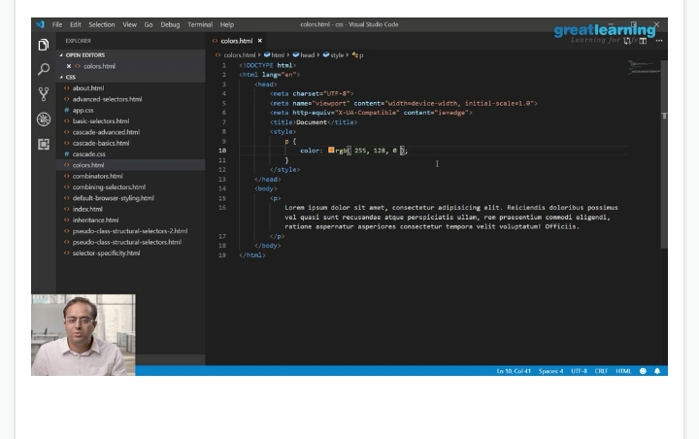

3) coding challenges

#include <stdio.h>

void main()

{

int arr1[50][50],brr1[50][50],crr1[50][50],i,j,k,r1,c1,r2,c2,sum=0;

printf("\n\nMultiplication of two Matrices :\n");

printf("----------------------------------\n");

printf("\nInput the rows and columns of first matrix : ");

scanf("%d %d",&r1,&c1);

printf("\nInput the rows and columns of second matrix : ");

scanf("%d %d",&r2,&c2);

if(c1!=r2){

printf("Mutiplication of Matrix is not possible.");

printf("\nColumn of first matrix and row of second matrix must be same.");

}

else

{

printf("Input elements in the first matrix :\n");

for(i=0;i<r1;i++)

{

for(j=0;j<c1;j++)

{

printf("element - [%d],[%d] : ",i,j);

scanf("%d",&arr1[i][j]);

}

}

printf("Input elements in the second matrix :\n");

for(i=0;i<r2;i++)

{

for(j=0;j<c2;j++)

{

printf("element - [%d],[%d] : ",i,j);

scanf("%d",&brr1[i][j]);

}

}

printf("\nThe First matrix is :\n");

for(i=0;i<r1;i++)

{

printf("\n");

for(j=0;j<c1;j++)

printf("%d\t",arr1[i][j]);

}

printf("\nThe Second matrix is :\n");

for(i=0;i<r2;i++)

{

printf("\n");

for(j=0;j<c2;j++)

printf("%d\t",brr1[i][j]);

}

for(i=0;i<r1;i++)

for(j=0;j<c2;j++)

crr1[i][j]=0;

for(i=0;i<r1;i++)

{

for(j=0;j<c2;j++)

{

sum=0;

for(k=0;k<c1;k++)

sum=sum+arr1[i][k]*brr1[k][j];

crr1[i][j]=sum;

}

}

printf("\nThe multiplication of two matrices is : \n");

for(i=0;i<r1;i++)

{

printf("\n");

for(j=0;j<c2;j++)

{

printf("%d\t",crr1[i][j]);

}

}

}

printf("\n\n");

}

|  |
| --- |
|  |
|  |  |
|  |  |
|  |  |
|  |  |
|  |  |